**LAPORAN MINGGUAN PEMROGRAMAN 1**

**PRAKTIKUM 2**

**Nama : Aldi Reza Sastrawan**

**NPM : 4513210004**

1. **Materi 1**

**Source-code**

public class lulus{

public static void main (String[]args){

int nilai=60;

if(nilai>50){

System.out.print("Selamat Anda Lulus");

}

else System.out.print("Maaf Anda Tidak Lulus");

}

}

**Screenshoot**

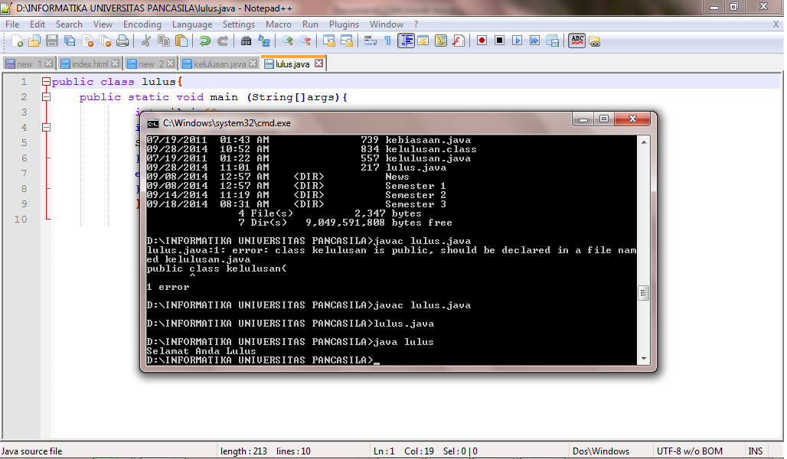

**2. Materi 2**

**Source-code**

import java.util.Scanner;

public class kelulusan{

public static void main(String[]args){

int nilai;

Scanner input = new Scanner (System.in);

System.out.print("\nMasukkan Nilai :");

nilai = input.nextInt();

if ((nilai<49 && nilai>0)){

System.out.println("Nilai Anda Jelek !");

}

else if (nilai == 50){

System.out.println("Sedang");

}

else if ((nilai>51 && nilai<100)){

System.out.println("Selamat anda lulus");

}

else {

System.out.println("Ga usah kuliah");

}

System.out.println ("keluar");

}

} else System.out.print("Maaf Anda Tidak Lulus");

}

}

**Screen-shot**

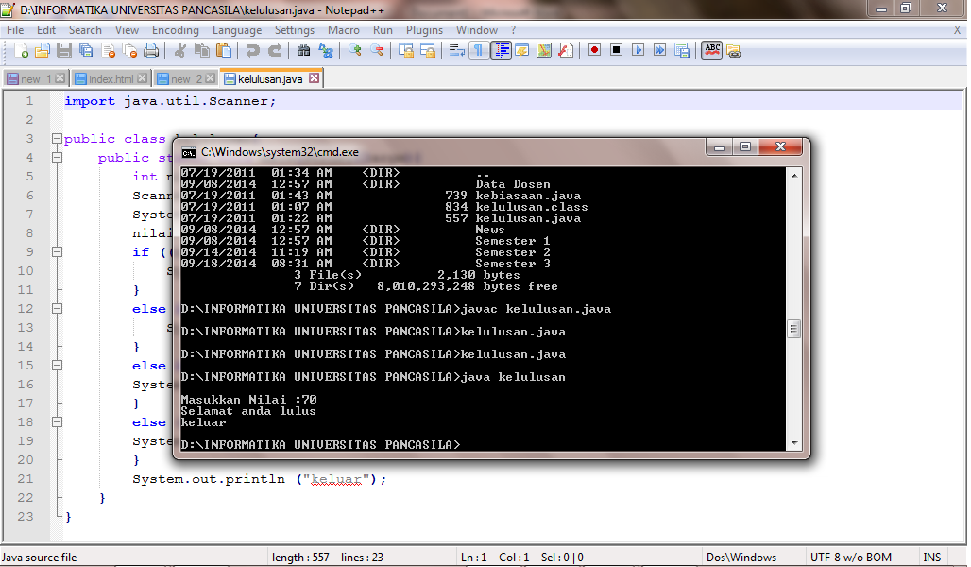

**3. Materi 3**

**Source-code**

import java.util.Scanner;

public class kelulusan3{

public static void main(String[]args){

int nilai;

Scanner masuk=new Scanner(System.in);

System.out.print("Masukkan nilai= ");

nilai=masuk.nextInt();

if(nilai<50){

System.out.println("Jelek");

}

else if(nilai==50){

System.out.println("standart");

}

else if((nilai>50) &&(nilai<=99)){

System.out.println("Lulus");

}

else if(nilai==100){

System.out.println("Comlude");

}

else System.out.println("nilai tak terdefinisi");

}

}

**Screen-shot**

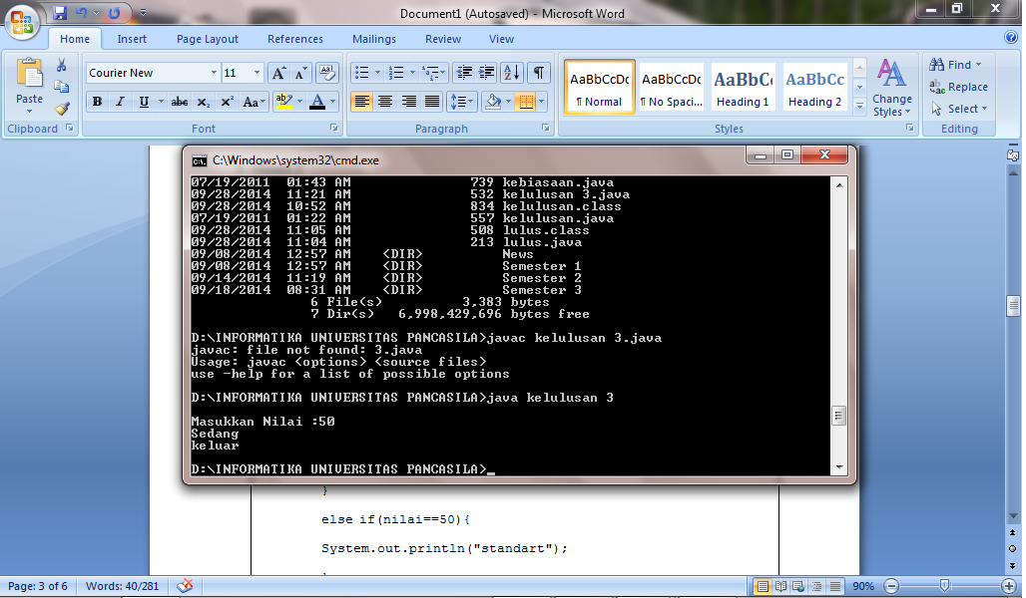

**4. Materi 4**

**Source-code**

import java.util.Scanner;

public class kebiasaan{

public static void main(String[]args){

int pilih;

Scanner masuk=new Scanner(System.in);

System.out.print("Pilihan : \n");

System.out.print("1. Makan \n");

System.out.print("2. Mandi \n");

System.out.print("3. Tidur \n");

System.out.print("4. Jalan - Jalan \n");

System.out.print("Masukan Pilihan Anda = \n");

pilih=masuk.nextInt();

switch(pilih){

case 1: System.out.print("Saya Suka Makan");

break;

case 2: System.out.print("Saya Suka Mandi");

break;

case 3: System.out.print("Saya Suka Tidur");

break;

case 4: System.out.print("Saya Suka Jalan - jalan");

break;

default: System.out.print("Menu Tidak Ada");

}

}

}

**Screen-shot**

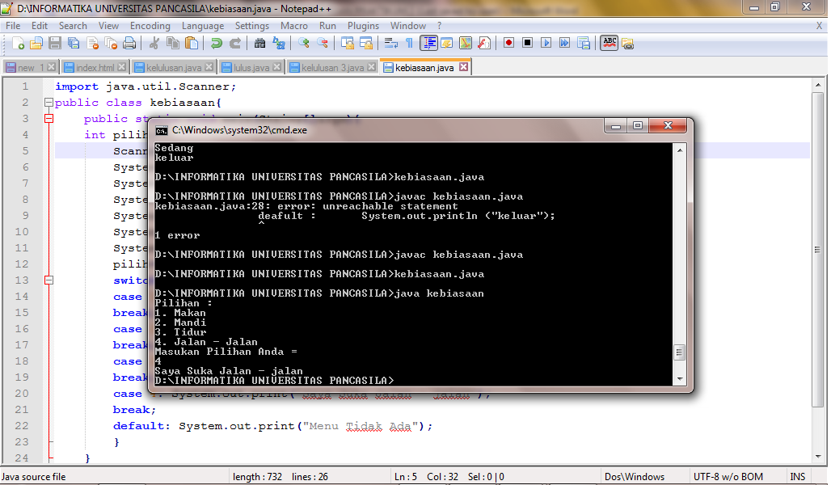

**5. Materi 5**

**Source-code**

import java.util.Scanner;

public class nilai{

public static void main(String[]args){

int nilai;

Scanner masuk=new Scanner(System.in);

System.out.print("Masukkan nilai= ");

nilai=masuk.nextInt();

if(nilai==10){

System.out.println("Sepuluh");

}

else if(nilai==20){

System.out.println("Dua Puluh");

}

else if((nilai!=10) &&(nilai!=20)){

System.out.println("Bukan 10 & 20");

}

else System.out.println("nilai tak terdefinisi");

}

}

**Screen-shot**

